**Game Warrior Gaming Websites**

That history of multiplayer games dates back to the early days of carton-based computer networking in the 1970s. An excellent example of multiplayer games is MUDs, including the last one, MUD1, developed in 1978 and initially limited to a corporate network until being linked to Arpanet in 1980.

Now we discuss all pages that are included in this websites.

1. **Home.html**

When we equate 10-year-old video games and current games, you will realize a major gap around their technological and visual capacities. The video games industry produces thousands of updated games each year, which are in sync with the times. Via good user experiences and design standards designers are attempting to create a pleasant and pleasant customer experience. Heroes and landscapes are becoming more practical year after year. Plus, along with video games, game sites are developed and updated. In this article, we will describe in depth the types of game websites and introduce 10 stunning examples of designing game websites.

The video game industry is on track to produce a mere $135 billion shy in 2018. This is according to industry experts study New zoo and discussed with GamesIndustry.biz for the report 2018 version of our Year In Statistics. The market value of $134.9 billion represents an rise of 10.9 per cent over 2017. The video games industry is rising so fast that by 2025, some say it will hit more than $300bn. With trillions of dollars in income and more than 2.5 billion players around the world, we should expect to start improving video game services in 2020.

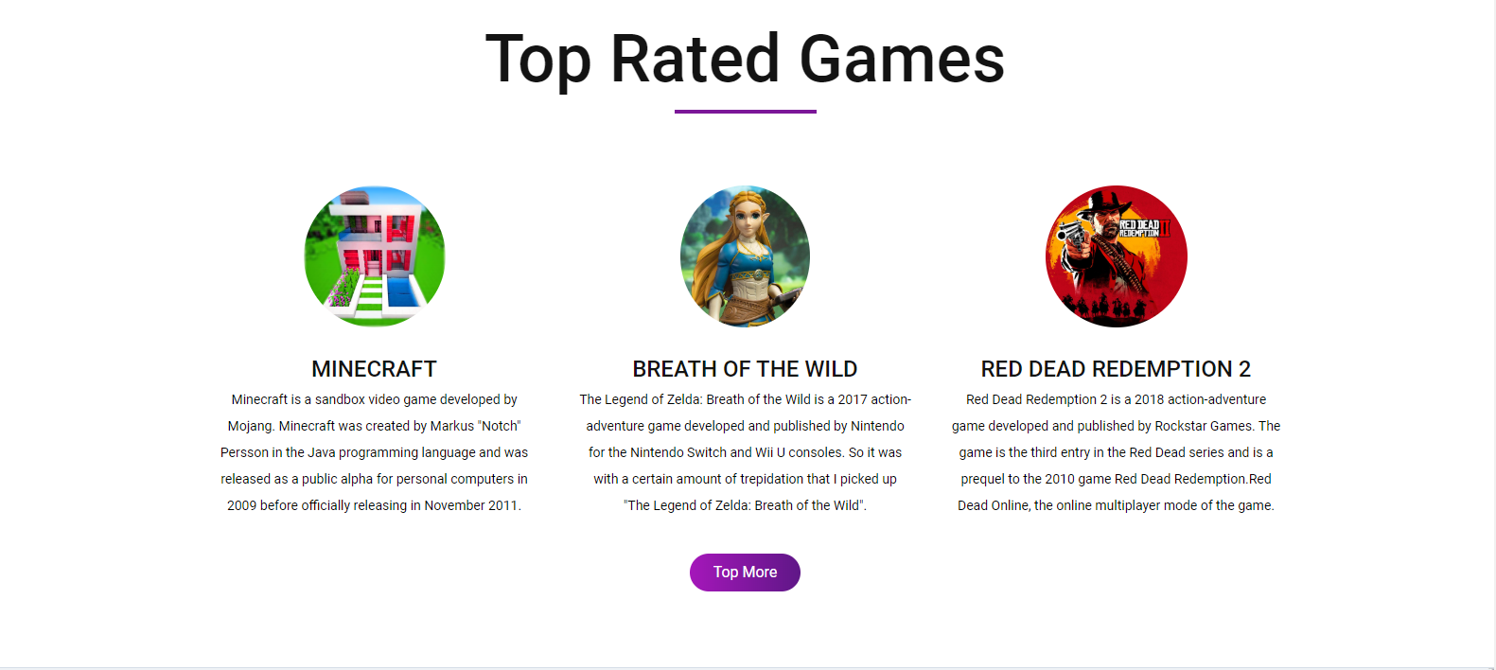

**Recent Games**

Gears Tactics is a turn-based tactics computer game produced by Splash Damage and released by Xbox Game Studios in collaboration with The Coalition. It is a Gears of War series turn-off and a spinoff to the first match, and was published on April 28, 2020 for Microsoft Windows

Streets of Wrath 4 is a video game beat 'me up created by Dotemu, Lizardcube, and Guard Stomp Games. The game is a direct consequence of Sega's Streets of Rage series, a film series of games available for the Sega Genesis during the early 1990s.

Someday you’ll yield is a video game of psychological horror, developed by CBE Software. The game is inspired by Silent Hill, Outlast 2, and The Devastation of Ethan Carte.

1. **About.html**

Believe to doing business in honesty Believe in True Workers Worker Believe in Hard work and nothing is impossible we have a plan for the future and believe that no one will bother you if you are hardworking Believe in doing business with integrity Believe in doing business with fairness.

In 2018, video game profits achieved a new peak of $43.8 billion, up 18 for each cent from past years, surpassing the forecasted global opening weekend for the movie industry, based on the most recent new data published by the Television Software Connection and the NPD Group. Gaming is on the verge of becoming the world's most important entertainment market. As per research by IDG, gaming now generates more sales globally than the music industry.



The video games industry is the sector of the economy that engages in video games production, marketing, and monetization. It comprises hundreds of work fields, and its constituent parts hire thousands of people across the world. As of 2018, computer games had produced worldwide annual sales of US$ 134.9 million.

1. **Categories.html**

While some longtime childhood classics are still common, there is also dominance in violence in video games like multiplayer shooters, which may be a concern for parents. That is why each video game come with the Video Software Rating Management's age and quality ranking, making it important for parents to inform itself about these scores, so they can determine the computer games are suitable for their baby. "Video games get a lot of attention, but parents should also bear in mind the other areas where their children may be subjected to violence such as movies, television and the Internet. Laws have to call at the end of the day when it comes to their children and violent video games,”

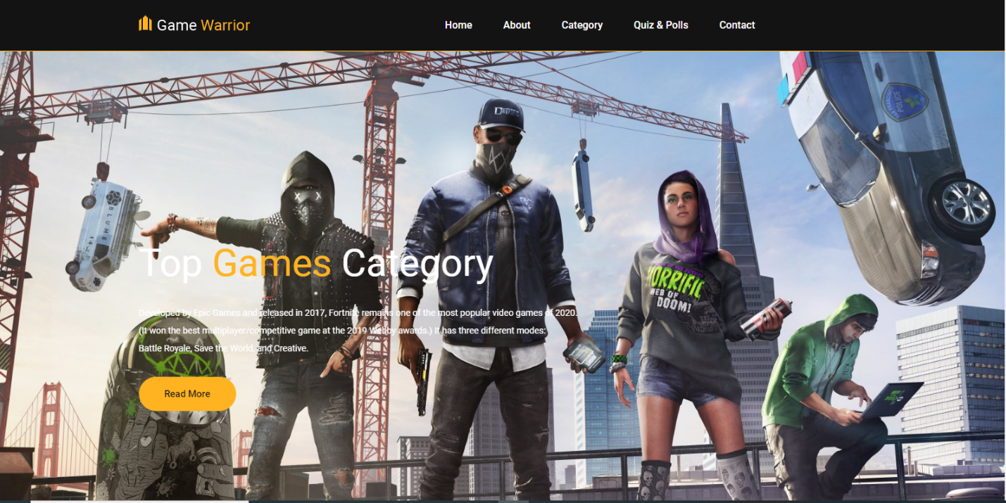

**Call of Duty:** Modern Warfare This Activision-published 1st-person shooter game is the 16th installment in the Modern warfare series. It's released for Microsoft Windows, Console 4 and Xbox One in October 2019. The plot is followed by a CIA agent and British forces teaming up to try and save Urzikstan's fictional nation from occupation.

RELATED: 50 + Gifts for Boys Which Words Too Cool.

**NBA 2K20** This game simulation software is released by 2 K Sports and is centered on the Regional Basketball Organization. It is the 21st iteration of the NBA 2 K series, following NBA 2K19 (you guessed that). The game went out for Operating systems, Nintendo Switch, PlayStation 4, and Xbox One in Nov 2019.

**Madden NFL 20** Centered on the English premier league, this football simulation game released by Electronic Arts is. This variant, released for PlayStation 4, Xbox One and Windows vista in August 2019, is the newest in the Franchise mode NFL series.

**Mortal Combat 11** This battle game was released by Warner Bros. Interactive media for Operating systems, Nintendo Switch, PlayStation 4 and Xbox One came out in April 2019. It is the 11th overall instalment in the series Mortal Combat, following the publication of Mortal Combat X, in 2015.

1. **Quiz.html**

**Online games Billiards Quiz and Pools** is not a new type of playing. It's been played by people for centuries and is a common activity in bars and pubs. Digital pool has been there for just over a couple of decades, however. As a Flash game on Candy stand the genre has developed quite a bit from its days. A lot of digital qualifying games are available now and smartphone models aren't that bad. You can also play various pool styles like 8-ball, Snooker, Carrom, Crokinole and a bunch of everyone else. Here are Device's Best Pool or Billiard Games! Although older games such as Space flight claim to become the first mobile game in the world, only one can be considered the first "popular video game" in the world which is Pong. Which was really simply a game of table tennis. Children these days would never be able to sit down and play Table tennis for as long as children of the 70s did. But that is because times change and video games are like that. That's why the quiz today will be recognized by someone who is anyone on modern video games. Or at least anybody in the gaming community whoever is. But let's talk about popularity, before we start. Pong was the very first popular platform, but only one can be a much more popular game. And that game is Tetris, with more than 170 million transactions / downloads.



**From whence is Road hog?**

Even see the personality there way over? His nickname is Road hog and in this First Person Shooter game he's a favorite fan. His chain hook pulls enemies close so that with his scrap gun, he can shred them. In 2016 it was Game of the Year almost regularly, including at Game Informer as well as the Community Awards. It was the greatest game of 2016, with very little or no contest, everybody decided. What game includes this Road hog character alongside Tracer, Mercy and Sombra?

1. **Contact.html**

The global demand for the video games industry is expected to rise by US$ 119 globally. 8 Millions, powered by a 9-fold compound rise. One percent. One of the categories evaluated and scaled in this report, Dungeon crawlers demonstrates the capacity to rise at over 13.



The United States, reflecting the developing world, will sustain a rate of economic growth of 7.2 per cent. Within Europe, which remains an important element in the economy, Germany will be adding more than US$ 4 trillion to the diameter and clout of the region within the next 5 to 6 years. Over US$ 3.2 trillion of the region's estimated demand will come through markets throughout Rest of Europe. In Japan, by the end of the review era, Mobile Games will hit a market size of US$ 7.1 trillion. As the market in the world-largest economy and the latest game shift in global markets, China has the potential to increase at 14.7 percent over the next few years and add roughly US$ 38.6 trillion to addressable opportunities.